***BAHRIA UNIVERSITY KARACHI CAMPUS***

**OBJECT-ORIENTED PROGRAMMING LAB**

**PROJECT REPORT**

**SPRING - 2022**

**COMPLAINT MANAGEMENT SYSTEM**

**GROUP MEMBERS**

Abdul Hadi Waseem (02-134212-091) (BS CS - 2A)

Muznah Adnan Sheikh (02-134212-024) (BS CS - 2A)

Maaz Abdullah (02-134212-014) (BS CS - 2A)

SUBMITTED ON

6 July, 2022



**INTRODUCTION:**

A Complaint Management System is a Software Application that allows businesses to manage a more efficient way to respond to consumer queries, provide consistent service and manage complaints. What we’re working on is a Complaint Management System that is designed specifically for a tech company that would deal with complaints involving every part of the tech company such as resolving technology and software complaints, HR or harassment complaints, user complaints. Implementing it in your technology company or actually any company in general can be really fruitful towards the development of company and can have many benefits. The main objective of the system is to identify the issues that are affecting the internal operations of the IT company. It should also be able to provide the necessary help to the staff members by improving the efficiency of the organization. This method eliminates the need for the staff members to manually enter information and provides them with the necessary tools to improve the efficiency of their work.

Our Complaint Management System is solely developed to work for an IT Company and its employees. It provides an online way of solving the problems faced by the employees by saving time. The objective of our Complaint Management System is to make complaints easier to coordinate, monitor, track and resolve, and to provide the IT company with an effective tool to identify and target problem areas, monitor complaints handling performance and make business improvements. By this system the employee can save his time and solve their concerns without going to an Admin Officer. They can get their problem solved by posting the problem in this proposed system and the Admin can suggest a possible solution to the problems posted on the system.

**FLOW-CHART:**

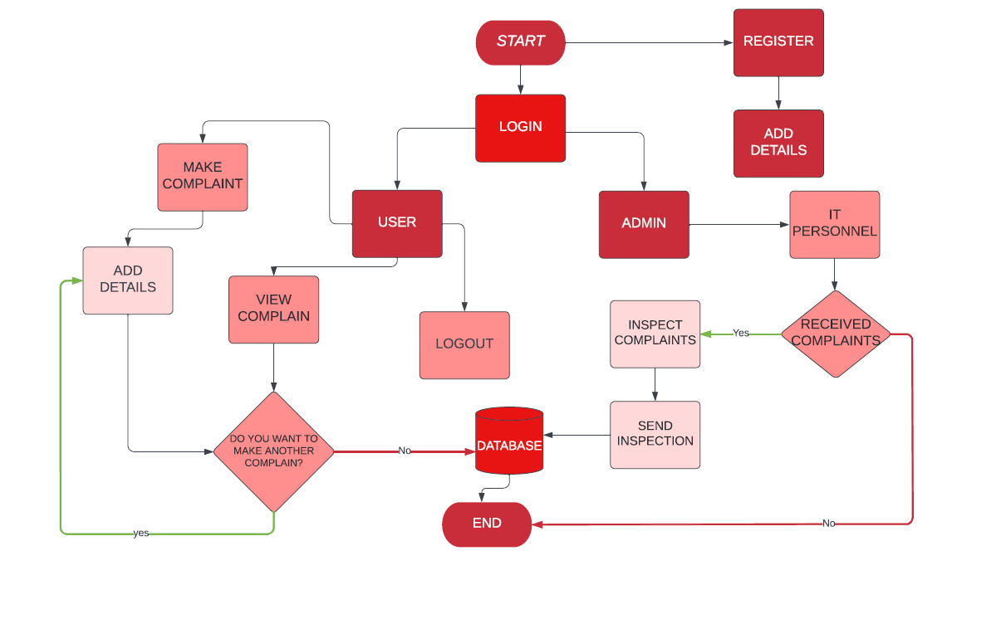

**UML CASE DIAGRAM:**

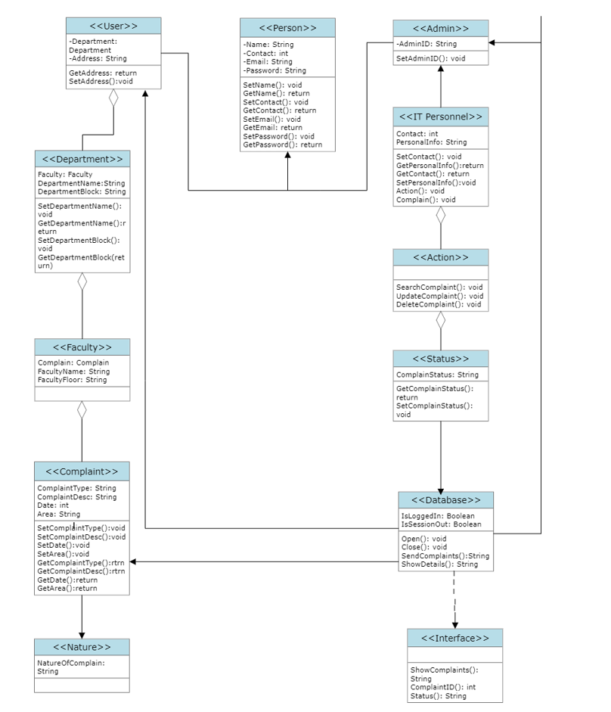

**MODULE DESCRIPTION:**

1. **User Screen**

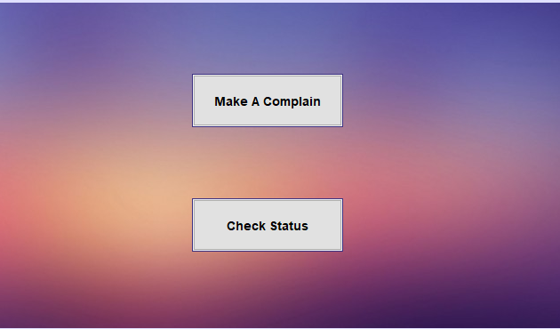

1. **User Panel**

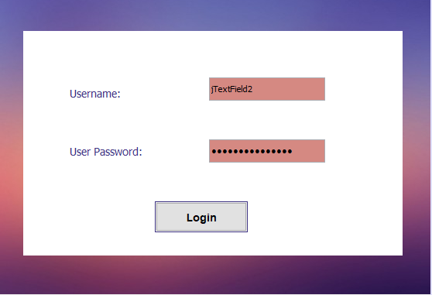

1. **Sign Up**
2. **Search User**

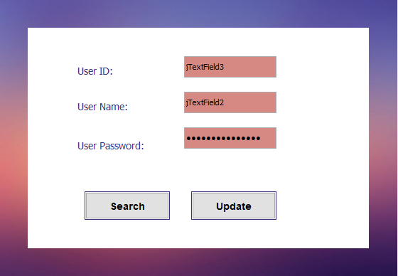

1. **Main GUI**

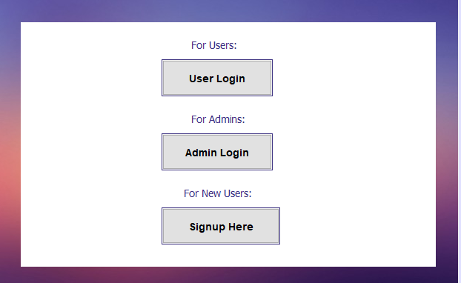

1. **Delete User**

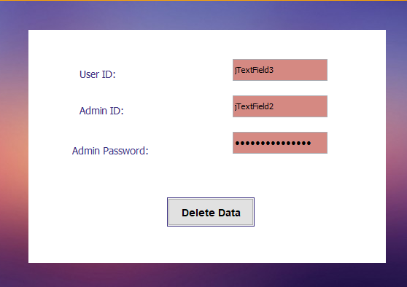

1. **Complain Form**
2. **Check Status**

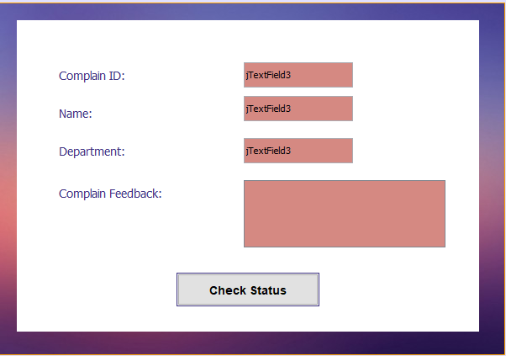

1. **Admin Screen**

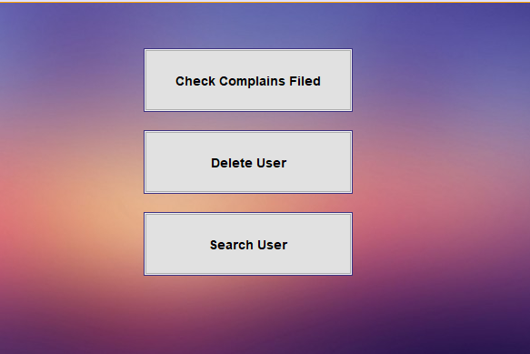

1. **Admin Panel**

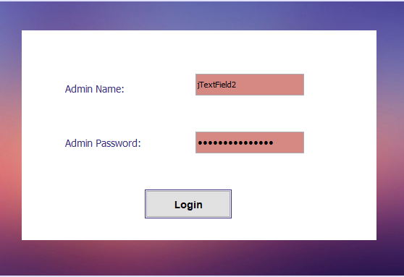

1. **Admin Complain Check**

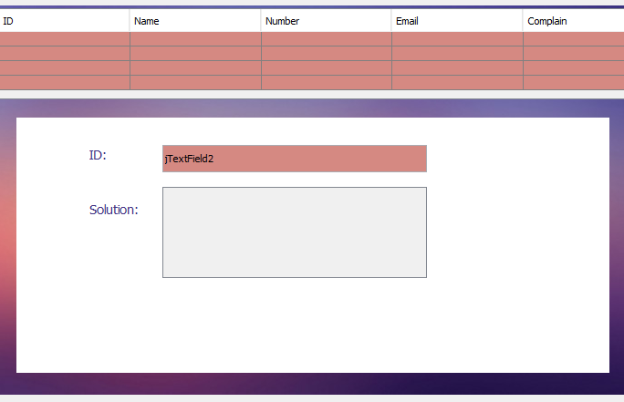

**FEATURES APPLIED:**

**(things such as file handling, inheritance, polymorphism etc)**

**HARDWARE REQUIRED:**

**(system requirements)**

**SCREEN DESIGN:**

**(ss of system)**

**CONCLUSION:**

Our Complaint Management System's easy access and flexibility allow the admin to maintain a constant contact with the employees even if they are not in the office. It also saves them time and money by allowing them to communicate with their employees through an online platform.